Title of the paper (bold, 14-pt Times New Roman, centered. Do not use capital letters for the beginning of each word.)

Presenting Author Name Surname¹, Co-authors Name Surname² (bold, 12-pt Times New Roman, left aligned)
¹Affiliation 1 (11-pt Times New Roman, italic, left aligned)
² Affiliation 2 (11-pt Times New Roman, italic, left aligned)
Corresponding author email (11-pt Times New Roman, italic, left aligned)

Page size: A4 (21.0 x 29.7 cm); margins: top and bottom 2.0 cm, sides 2.3 cm. Total abstract length should NOT exceed 1 PAGE. File name should be set as follows: LastName_FirstName_(submission number: 1, 2 or 3)_(presentation type abbreviation: O for oral or P for poster presentations), e.g.: Smith_Anne_1_P.
Division of main body of abstract into sections – as presented below – is not obligatory.

INTRODUCTION, EXPERIMENTAL, RESULTS AND DISCUSSION, CONCLUSIONS (HEADING: 11-PT TIMES NEW ROMAN, BOLD, JUSTIFIED)
Type the body of the abstract text single-spaced in 11-pt Times New Roman, justified. The first line of each paragraph should be indented 5 mm. Do not number headings or subheadings; leave no empty lines between heading or subheading and following text.

Figures and tables (subheading: 11-pt Times New Roman, bold, justified)
Figures and tables should be centered. Insert figures in gif, jpg, png or tiff format, with at least 300 dpi resolution; images of good quality should be used, and any lines, axes or signs on the figures should be clearly visible. Type the text in the tables single-spaced in 10-pt Times New Roman.

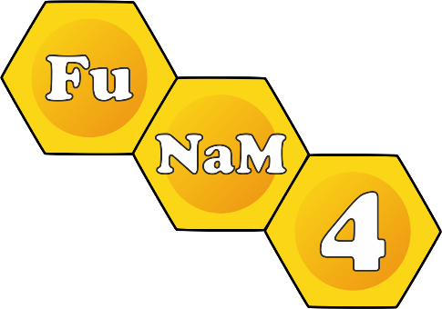
An example of figure and table captions. (10-pt Times New Roman, italic, centered)

Acknowledgements
Type acknowledgements single-spaced in 11-pt Times New Roman, justified.

References
References should be placed in the text in square brackets [1]. Using automatically numbered lists is not recommended. The list of references should be placed at the end of the text as separate section titled ‘REFERENCES’. Type each reference single-spaced in 10-pt Times New Roman, left aligned.

REFERENCES (HEADING: 11-PT TIMES NEW ROMAN, BOLD, JUSTIFIED)
1. J. Kowalski, Nature 374 (1995) 42
2. J. Smith, A. Kowalska, Micropor. Mesopor. Mater. 47 (2001) 157

